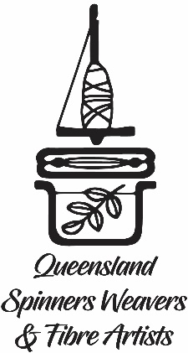

Queensland Quarantine Quilt
Submission Form
Your submission MUST be received at ABC Studios Southbank by 5 pm Friday 5 June 2020.
Post Directly to ABC Radio Brisbane, Queensland Quarantine Quilt, GPO 9994, Brisbane 4001

Name:
Suburb:
Phone:
Email:
What fibres have you used?

What techniques you have used?

How does your block represent what the quarantine period meant to you? (in 50 words or less)

By entering your piece for this art exhibit, you relinquish ownership of the artwork. Your first name and suburb will form part of the artwork on display. Your surname and contact details will be used only for editorial purpose and contacting the artists regarding their work. Ownership will belong to ABC Radio Brisbane to be used at their discretion including publicity purposes in perpetuity. Should there be an excess of submissions, all artwork pieces will be ‘juried’ for selection in the final Queensland Quarantine Quilt. Artworks not used in the quilt shall remain the property of ABC Radio Brisbane to be used and/or assigned at their discretion.
- No, I don’t wish to get the occasional email from Queensland Spinners about their events.
I agree to these terms,
Signed: Date:

